|  |  |
| --- | --- |
| **Project Name** | Online Survey System |
| **Objective** | Online Survey System Project is a web-based application developed in Java programming language to facilitate online survey. The main aim of the project is to form a platform to collect the viewpoints of related people about certain issue using the internet. Along with launching survey, it is capable of giving e-mail notifications. It can be implemented in any organizations or college for carrying out survey of any kind. |
| **Platform** | Web-app |
| **Front End** | Html, CSS , Servlets, JSP |
| **Back End** | MySQL Database |

------------------------------------------------------------------------------------------------------

**HARDWARE REQUIREMENT**

**Client side:**

|  |  |
| --- | --- |
| **RAM** | 2-4 GB |
| **Hard disk** | 10 GB |
| **Processor** | 2.0 GHz |

**Server Side:**

|  |  |
| --- | --- |
| **RAM** | 2-4 GB |
| **Hard disk** | 20 GB |
| **Processor** | 2.0 GHz |

------------------------------------------------------------------------------------------------------

**SOFTWARE REQUIREMENT**

**Client side:**

|  |  |
| --- | --- |
| **Web Browser Google, Mozilla Firefox etc.** |  |

**Server side:**

|  |  |
| --- | --- |
| **Web Server** | Tomcat server |
| **Database Server** | MySql |
| **Other Softwares** | Eclipse, Mysql-Workbench , Java |

------------------------------------------------------------------------------------------------------

**FUNCTIONAL SPECIFICATIONS:**

**User Specification:**

Admin : can add a survey page .

User : User can create an account and he can login with his valid credentials which was given by him while registering the account .

Survey : It helps the users to find information on the user’s interest survey .

------------------------------------------------------------------------------------------------------

**MODULE SPECIFICATION :**

**Student Education :**The user will get the information regarding the career choice’s he has in his education field.

**Agriculture: The user will get to know the types of agricultures and it’s importance**

Tourism : The user can know the exciting places around the India .

**Feedback** : The user can grade a points of 1- 10 on a scale .

**Contact us** : It display’s the admin details and works .

**Logout**: It helps the user’s to logout of their accounts .

------------------------------------------------------------------------------------------------------

**E-R DIAGRAM**

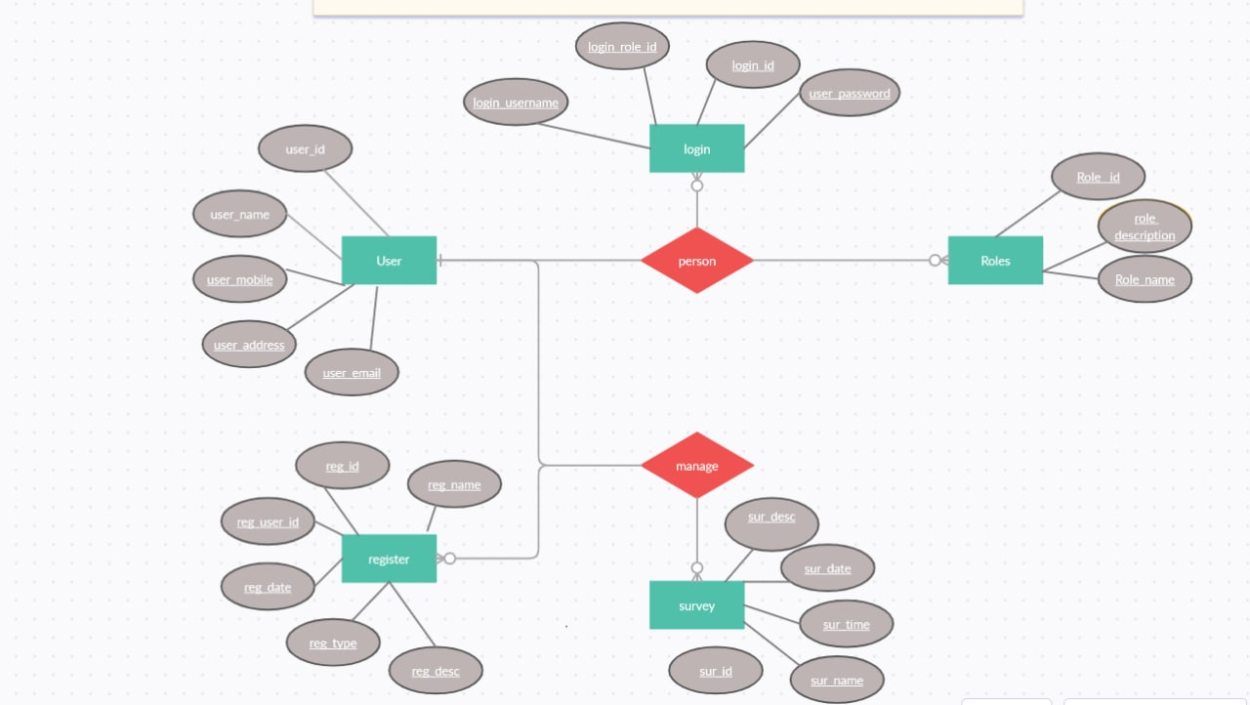

------------------------------------------------------------------------------------------------------

**UML DIAGRAMS**

**.Use Case Diagram**

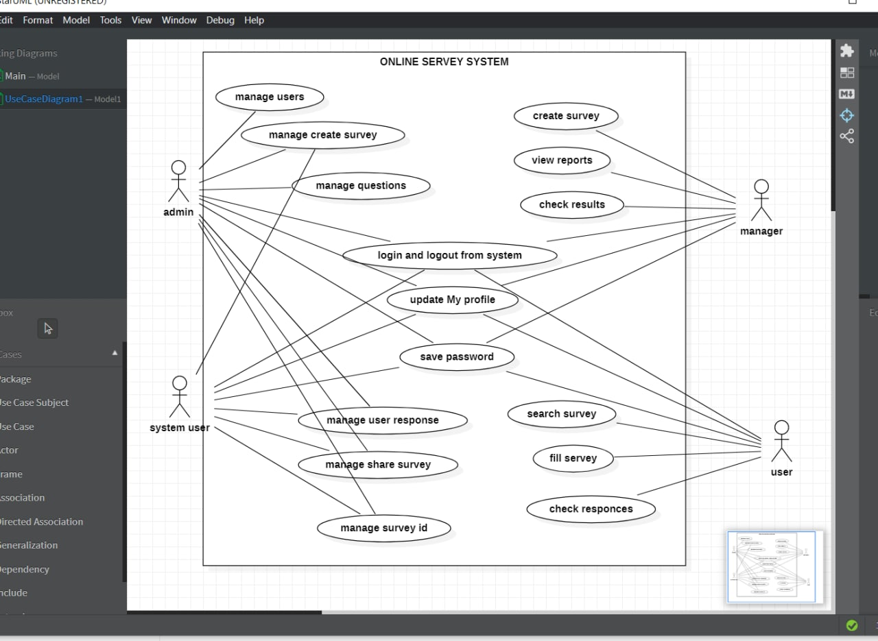

------------------------------------------------------------------------------------------------------

**Class Diagram**

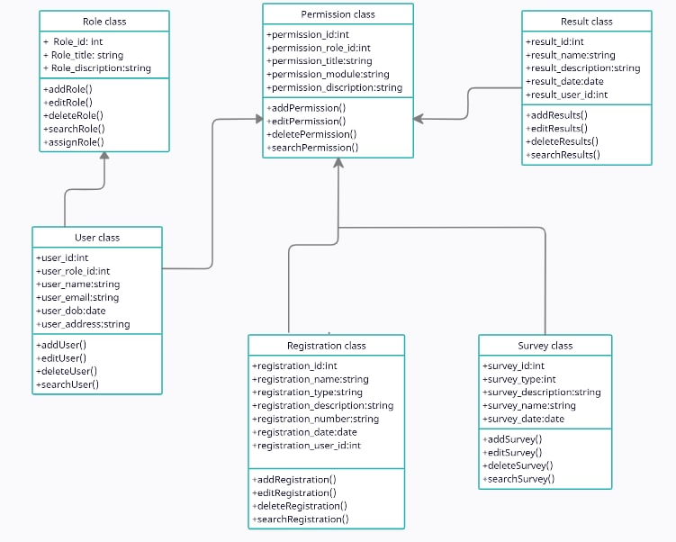

------------------------------------------------------------------------------------------------------

**DATA DICTIONARY :**

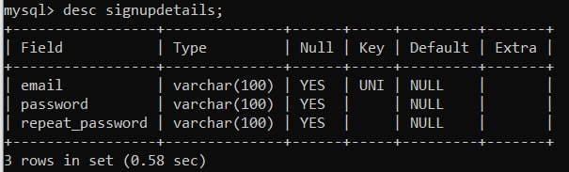

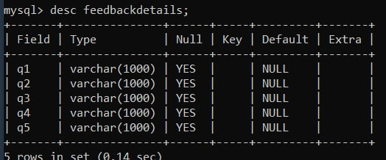

------------------------------------------------------------------------------------------------------

**POST IMPLEMENTATION**

* The website application is  self maintained.
* There is no need provide post implementation support.
* The admin can access add, edit, delete process.

**FUTURE ENHANCEMENT**

* Add new Interesting surveys

------------------------------------------------------------------------------------------------------